

Capstone Project 2

Blood Cell Classification - CNN Project with ResNet Layer



August 14, 2022

Anand Rajan

# **Abstract**

The goal of this project is to accurately determine the type of blood cells in the given images. In the real world, these images are captured under microscopes. There are 4 types of cells that we are training the neural network to learn to identify. The use of using CNN to identify different blood cells can be useful so that the process of identifying changes in the number of blood cells can be done quickly and accurately using deep learning. This is extremely vital in real world scenarios requiring quick and autonomous statistics for resultant diagnoses.

Table of Contents

**Abstract** 1

**Introduction** 3

**Understanding the technology** 4

**Architecture** 6

**Performance plotting** 6

**References** 6

# **Introduction**

Hemopathology (hemo means blood, pathology means disease), is the study of studying diseases through blood cells. Abnormal blood cell structure, the level of the number of blood cells, and so on, are some of the factors that can be used to identify some diseases.

Some diseases, such as leukemia, dengue fever, thalassemia, malaria, not to forget the most infamous example of recent times that is CoViD-19, have marked changes in the white blood cell count. This is because some types of white blood cells can only fight certain types of disease. Changes in the number of these cells can be used to identify the disease. The dataset contains four types of blood cells, namely: Eosinophils, Lymphocytes, Monocytes, Neutrophils.

The programmed neural network will be trained on over 9000 images, with similar number of images per cell. The trained ResNet will then test its ability to appropriately recognize over 2000 images. We strive to find as high a point of accuracy as possible, with some tweaking of parameters and more training.

# **Understanding the technology**

There are four layers in CNN:

1. Convolutional Layer - the layer that performs a convolutional operation, creating several smaller picture windows to go over the data.
2. ReLU Layer - it brings non-linearity to the network and converts all the negative pixels to zero. The output is a rectified feature map.
3. Pooling Layer - pooling is a down-sampling operation that reduces the dimensionality of the feature map.
4. Fully Connected Layer - this layer recognizes and classifies the objects in the image.

The architecture of the model is something requiring careful consideration. It is important to understand a brief history of ResNet, or Residual Networks which is the core of this project. After the first CNN-based architecture (AlexNet) that won the ImageNet 2012 competition, every subsequent winning architecture started using more layers in a deep neural network to reduce the error rate.

This normally works for a small number of layers, but when we increase the number of layers too much, there is a common problem in deep learning associated with that called the Vanishing/Exploding gradient. This causes the gradient to become 0 or too large. Thus, when we increase number of layers, the training and test error rate also increases.

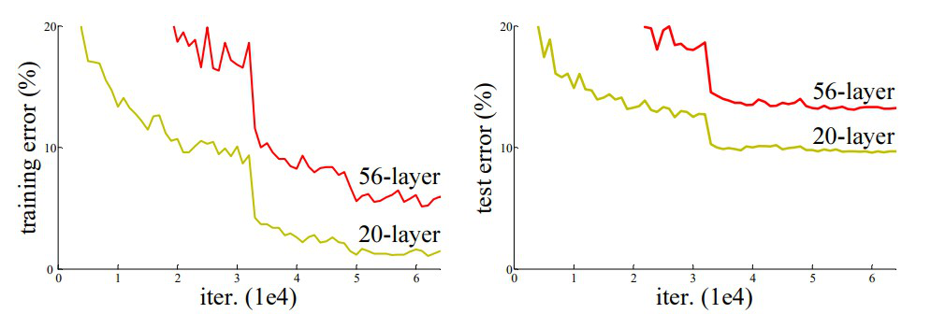

In the above plot, we can observe that a 56-layer CNN gives more error rate on both training and testing dataset than a 20-layer CNN architecture. After conducting more analysis on the higher error rates, the authors were able to reach the conclusion that it was caused by vanishing/exploding gradient.

Researchers at Microsoft Research introduced a new architecture called Residual Network in 2015.

# **Architecture**

# **Performance plotting**

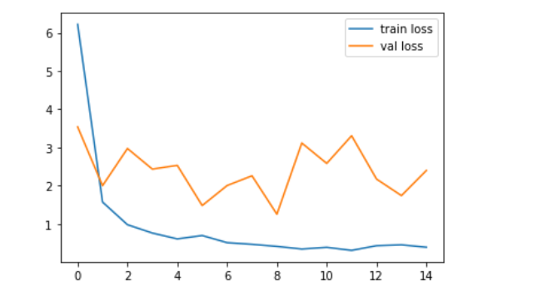

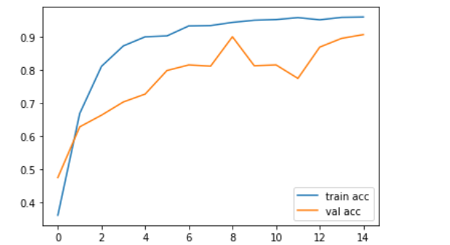

There’s a way to plot the confusion matrix with and without normalization. Simply by toggling the value of the normalize variable helps us achieve this.

# **References**

Google

Kaggle

GeeksForGeeks